|  |  |
| --- | --- |
| **Estd.1995** | **VALLURUPALLI NAGESWARA RAO VIGNANA JYOTHI**  **INSTITUTE OF ENGINEERING AND TECHNOLOGY**  VignanaJyothi Nagar, Pragathi Nagar, Nizampet (S.O), Hyderabad – 500 090, TS, India.  Telephone No: 040-2304 2758/59/60, Fax: 040-23042761  E-mail: [postbox@vnrvjiet.ac.in](mailto:postbox@vnrvjiet.ac.in), Website: [www.vnrvjiet.ac.in](http://www.vnrvjiet.ac.in) |

**DEPARTMENT OF AUTOMOBILE ENGINEERING**

**Guest Lectures**

**Academic Year 2019-20**

|  |  |  |  |  |  |  |
| --- | --- | --- | --- | --- | --- | --- |
| **S.No** | **Name** | **Designation** | **Affiliation** | **Topic** | **Date** | **Students** |
| 1. 6 | Mr. Sushant. T (Alumni) | Graduate Researcher | University of Cincinnati- USA | Current trends, opportunities and research scope for automotive engineers | 15/02/2020 | 97 |
| 1. 5 | Dr. Karunanidhi | Director-control systems laboratory | DRDO- Research centre, Hyderabad | Vidya (science of happiness)- Emotional intelligence | 25/01/2020 | 57 |
| 1. 4 | Mr. Krishna Prasad | Delivery Head | Tech. Mahindra- Hyderabad | Disruption in the industry – path forward for the budding engineers | 04/01/2020 | 96 |
| 1. 3 | Dr. Chidanadappa | Scientist | NRSC-Hyderabad | Trouble shooting and maintenance of Diesel power plants | 14/12/2019 | 92 |
|  | Mr. Pruthvignan Thota (Alumni) | Research Scholar | FhAachen University, Germany | Opportunities for higher educaton in Europe | 12/12/2019 | 43 |
| 1. 2 | Mr. PN Santhosh | Founder | BYJU's- Bangalore | Upskilling courses and certification progress | 11/09/2019 | 35 |
| 1. 1 | MRVSN Paramesh (Alumni) | Manager | Volve-Banglore | Life in Industry | 10/08/2019 | 50 |

**Academic Year 2018-19**

|  |  |  |  |  |  |  |
| --- | --- | --- | --- | --- | --- | --- |
| **S.No** | **Name** | **Designation** | **Affiliation** | **Topic** | **Date** | **Students** |
| 1. 6 | Dr. G. Naga Srinivasulu | Associate Professor | NIT WARANGAL | Fuel Cell Vehicles | 19/03/2019 | 91 |
| 1. 5 | Srikanth Kethu | Head of Mechanical Engineering | ZF ITC Hyderabad, India | Vehicle Safety-current and future trends | 01/03/2019 | 148 |
| 1. 4 | J.V. Madhavan | Manager | Adroitech-Secunderabad | Augmented reality technology | 21/02/2019 | 70 |
| 1. 3 | MRVSN Paramesh (Alumni) | Manager | Volve-Banglore | Future after B.Tech. | 29/09/2018 | 23 |
| 1. 2 | Nalla Sekhar | Head- Customer Quality Assuran | Mahindra & Mahindra Limited Zaheerabad | College to campus | 22/09/2018 | 63 |
| 1. 1 | Ramprasad L.V | Cofounder | Solar Aided Innovative Systems Pvt. Ltd | Automotive air conditioner | 18/09/2018 | 52 |
|  | Dr. AVSSKS Gupta | Professor | JNTUCE-Hyderabad | Fundamentals of FEM | 08/09/2019 | 70 |
|  | Dr. Satheesh Makkapati | Technical Expert | FORD-USA | Automotive propulsion- challenges and trends | 10/07/2018 | 100 |

**Academic Year 2017-18**

|  |  |  |  |  |  |  |
| --- | --- | --- | --- | --- | --- | --- |
| **S.No** | **Name** | **Designation** | **Affiliation** | **Topic** | **Date** | **Students** |
| 1. 6 | Mr. T. Pruthvignan | Student (Alumni) | FhAachen University, Germany | Opportunities Beyond | 09/03/2018 | 142 |
| 1. 5 | Mr. B. Saketh | Engineers | TATA AIG - Hyderabad | Placement readiness | 14/10/2017 | 40 |
| Mr. G. Swami Chandranath | Hyundai Mobi - Hyderabad |
| 1. 4 | Mr. Azad Hussain | Captain | Indian Army | Opportunities in Indian forces | 13/10/2017 | 58 |
| 1. 3 | Padmashri V. Gnana Gandhi | Rtd Assistant Director (Scientist) | ISRO -Trivandrum | Advanced green fuels in transport | 18/08/2017 | 73 |
| 1. 2 | KhuhsalSingh | Senior Research Associate | AMZ Automotive - Jaipur | Scope for automobile engineering students in motor sports | 03/08/2017 | 148 |
| 1. 1 | Dr. Ravikumar Puli | Professor | NIT Warangal | Modern trends in automobile | 22/07/2017 | 72 |

**Academic Year 2016-17**

|  |  |  |  |  |  |  |
| --- | --- | --- | --- | --- | --- | --- |
| **S.No** | **Name** | **Designation** | **Affiliation** | **Topic** | **Date** | **Students** |
| 1. 1 | Mr. K. Vinay Kumar | Student (Alumni) | Msc- in Mechanical engineering, Germany | Industry 4.O | 19/04/2017 | 48 |
| 1. 2 | Dr. B. Venkatesham | Associate Professor | IITH | Designing for quietness | 30/03/2017 | 43 |
| 1. 3 | Mr. Krishna Prasad B S | Delivery Head- Automotive (OEMs) | Tech Mahindra Technology Centre | Automotive trends and Disruptions | 28/03/2017 | 66 |
| 1. 4 | Dr. C. Bhasker | ES Sr Manager | BHEL R&d, Hyderabad | Modelling/CFD simulation techniques in mechanical engineering applications | 24/03/2017 | 101 |
| 1. 5 | Mr. D. Lalith Kumar | Manager | RAAM Honda | Road safety campaign | 20/02/2017 | 101 |
| 1. 6 | Padmashri V. Gnana Gandhi | Rtd Assistant Director (Scientist) | ISRO -Trivandrum | Advanced green fuels in transportation | 02/02/2017 | 103 |
| 1. 7 | Mr. V K Jaitley | Commander | Chairman C- cube consultants &  President IIT Kharagpur Alumni foundation | We can We can | 24/12/2016 | 91 |
| 1. 8 | Prof. G.V.S Sastry | Professor | IIT BHU | Bulk Ultrafine –Grained Interstitial-free steel pressed by Equal –Channel Angular Pressing and cryo rolling | 03/11/2016 | 66 |
| 1. 9 | Mr. D. Nagesh | Consultant | Sun Overseas  Hyderabad | Orientation program on overseas studies | 26/10/2016 | 52 |
| 1. 10 | Mr. Ramprasad LV | Manager | GE, Banglore | Basics of Refrigeration and air conditioning | 28/09/2016 | 85 |
| 1. 11 | Mr. HariharaIyer | Consultant | Consultant  Hyderabad | Automobile fuel efficiency | 02/10/2016 | 84 |

**Academic Year 2015-16**

|  |  |  |  |  |  |  |
| --- | --- | --- | --- | --- | --- | --- |
| **S.No** | **Name** | **Designation** | **Affiliation** | **Topic** | **Date** | **Students** |
| 1. 1 | Mr. SuhasKaul | Manager | Learned Consultancy  Hyderabad | Start-Up | 02/05/2016 | 88 |
|  | Prof. V. Vasudevarao | Professor | University of South Africa  Capetown | The role of nano- thermofulids in energy systems realization in real world | 12/01/2016 | 99 |
|  | Dr. Samuel GL | Professor | IIT Madras | Recent advances in manufacturing | 04/12/2015 | 77 |

**Academic Year 2014-15**

|  |  |  |  |  |  |  |
| --- | --- | --- | --- | --- | --- | --- |
| **S.No** | **Name** | **Designation** | **Affiliation** | **Topic** | **Date** | **Students** |
| 1. 1 | Mr. G. Sri Charan | Student (Alumni) | Powertrain Controls Engineer, John Deere, USA | Development of solar power assisted range extended electric vehicle | 15/04/2015 | 57 |
|  | Dr. S. Aslam Ansari | Chief Manager | Corporate office | Prevention of acscidents | 08/11/2014 | 45 |
|  | Sri. M. Ravinder | Executive Director | TSRTC | Fare collection systems | 06/11/2014 | 45 |
|  | Dr. S. Aslam Ansari | Chief Manager | Corporate office | Public relations | 31/10/2014 | 45 |
|  |  |  |  |  |  |  |
|  | Sri. G.N. Gnaneswara Rao | Chief Engineer | APSRTC | Operating cost and types of vehicles | 17/10/2014 | 45 |
|  | Sri. P. Brahmananda Rao | Dy. Chief Traffic Manager | APSRTC | Route planning and timing, bus working and schedules | 10/10/2014 | 45 |
|  | Sri. P. Brahmananda Rao | Dy. Chief Traffic Managers | APSRTC | Organisation and management | 27/09/2014 | 45 |

**Academic Year 2013-14**

|  |  |  |  |  |  |  |
| --- | --- | --- | --- | --- | --- | --- |
| **S.No** | **Name** | **Designation** | **Affiliation** | **Topic** | **Date** | **Students** |
| 1. 1 | Ms. Meghana | Consultant | CANTER CADD | Orientation program on CAD/CAM/CAE & Introduction to Pro-E | 20/02/2014 | 56 |
| 1. 2 | Dr.Ashok Agarwal | Chairman | EwB India | Engineers without Borders | 21/02/2014 | 96 |



Commander VK JAITLY, President IIT Kharagpur Alumni Foundation giving a guest lecture on “We can We can” (24/12/2016)



Padmashri V. Gnana Gadhi, ISRO-Trivandrum giving a guest lecture on Advanced Green fuels in transportation (02-02-2017)

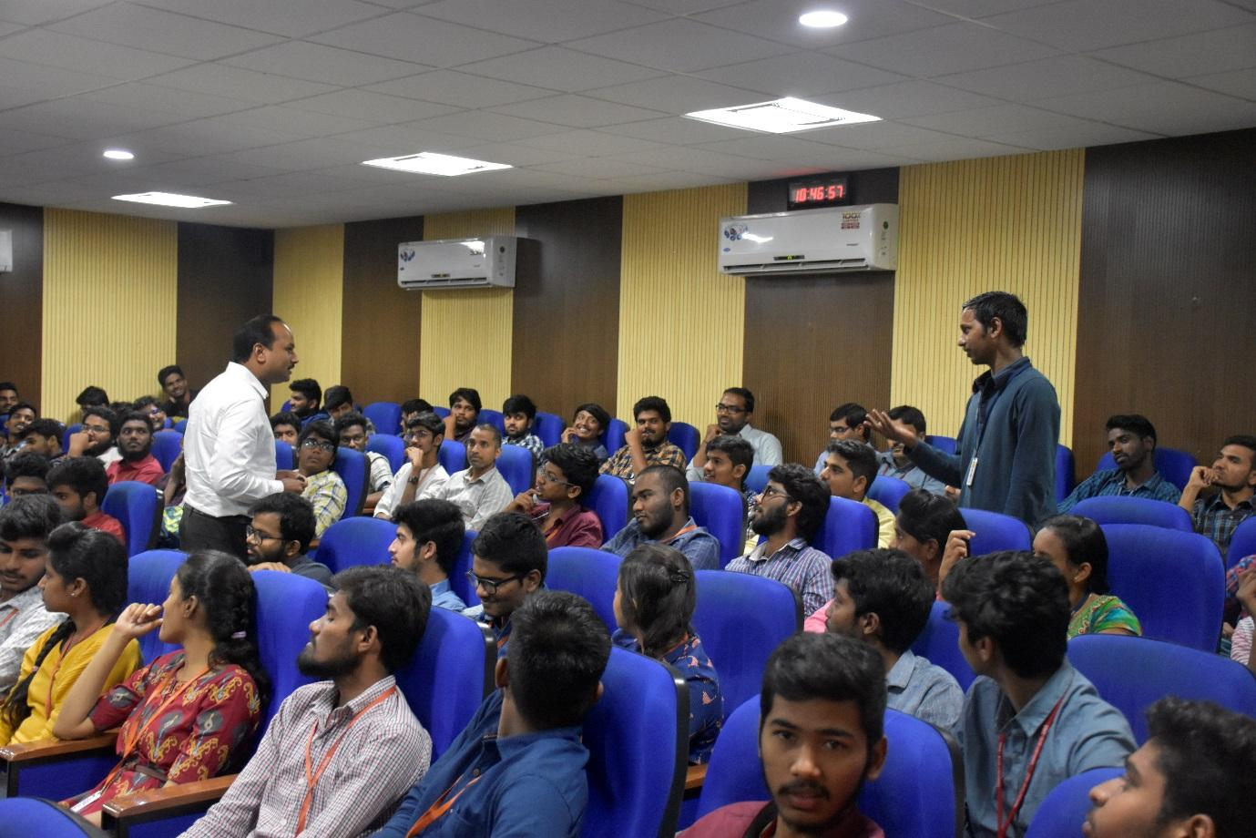

A guest lecturer is delivered by Mr. Srikanth Kethu, Head of Mechanical Engineering, ZF India Private Limited, India Technology Center, Hyderabad, Telangana 500032 on 01.03.2019 on “Vehicle Safety – Current and Future Trends”

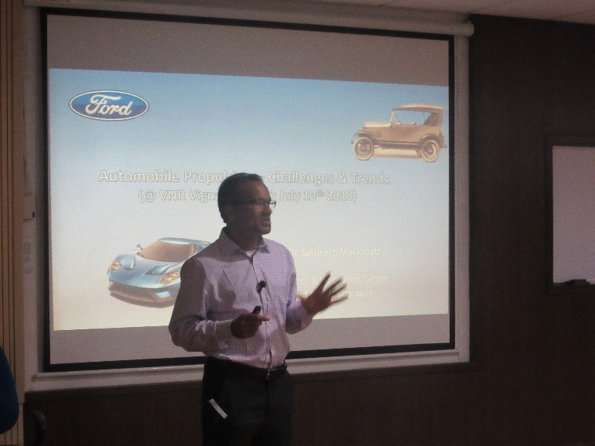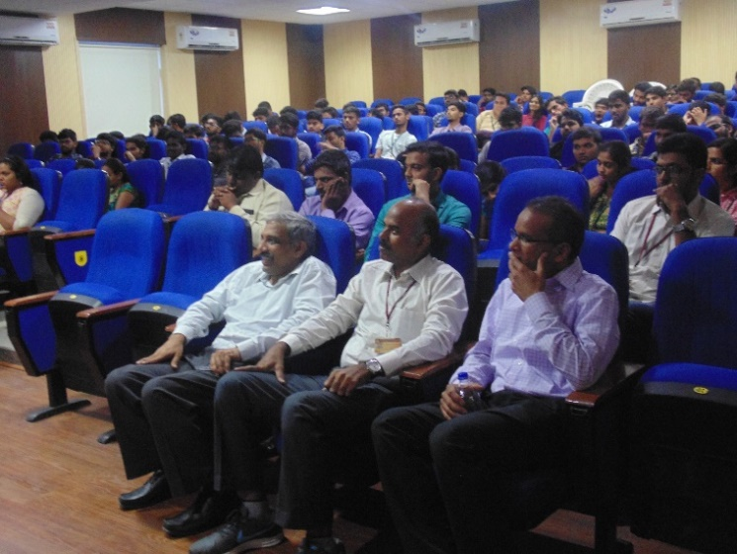

Dr. Satheesh Makkapati, Ford-USA has delivered a guest lecture on “Automotive propulsion - challenges and trends” on 10.07.2018

**Industry Experts Guest Lectures**

|  |  |  |  |  |  |  |
| --- | --- | --- | --- | --- | --- | --- |
| **Sl. No.** | **Industry Expert** | **Designation** | **Organization** | **Topic** | **Venue** | **Date** |
|  | Mr. Srikanth Kethu | Head of Mechanical Engineering | ZF India private ltd, Hyderabad | Vehicle safety-current and future trends | APJ Abdul Kalam Auditorium | 01-03-2019 |
|  | Mr. J V Madhavan | Sr. Manager Projects & Training | Adroitec,  Secunderabad | Augmented Reality Technology | D 403 | 21-02-2019 |
|  | Mr. Nalla Sekhar | Head- Customer Quality Assurance | Mahindra and Mahindra  Hyderabad | College to campus | D 405 | 22-09-2018 |
|  | Dr. Sateesh Makkapati | Subject matter expert in power train performance | Ford-USA | Automotive propulsion-challenges and trends | APJ Abdul Kalam Auditorium | 10/07/2018 |
|  | Mr. Swami Chandranath | Sr. Engineer | Hyundai Mobis R&D,  Hyderabad | Placement readiness | D-404 | 14/10/2017 |
|  | Captain. Azad Hussain | Captain | Indian Army | Opportunities in Indian forces | D-403 | 13/10/2017 |
|  | Padma Shri. V. Gnana Gandhi | Sr. Vice President – Propulsion, Skyroot Aerospace | ISRO Trivandrum | Green fuels in transportation | D-403 | 18/08/2017 |
|  | Mr. Kusal Singh | Senior Research associate | AMZ Group,  Jaipur | Scope for Automobile engineering students in Motor Sports | D-403 &  D-405 | 03/08/2017 |
|  | Mr. Ramprasad LV | Lead Engineer | GE India Technology Center,  Bengaluru | Basics of Refrigeration and air-conditioning | D-405 | 28/09/2016 |
|  | Commander V.K. Jaitley | Chairman | C_cube Consultants | We can! We can! | D-405 | 24/12/2016 |
|  | Padma Shri. V. Gnana Gandhi | Sr. Vice President – Propulsion, Skyroot Aerospace | ISRO Trivandrum | Advanced Green fuels in transportation | D-405 | 02-02-2017 |
|  | Mr. Lalith | Manager | Honda Motor cycle, Hyderabad | Road safety campaign | D-405 | 20/02/2017 |
|  | Mr. Bhaskar | Sr. Engineer | BHEL,  Hyderabad | Modelling/CFD simulation Techniques | D-405 | 24/03/2017 |
|  | Mr. Krishna Prasad B S | Delivery Head for Engg. services | Tech Mahindra,  Hyderabad | Discreting trends in Automotive | D-405 | 28/03/2017 |
| E:\Guest Lectuer\2018-19\Srikanth kethu\Photos\Photos - VNR_JAG0009.JPG | | | | | | |
| Fig.B.2.2.4a. A guest lecturer is delivered by Mr. Srikanth Kethu, Head of Mechanical Engineering, ZF India Private Limited, India Technology Center, Hyderabad, Telangana 500032 on 01.03.2019 on “Vehicle Safety – Current and Future Trends” | | | | | | |
|  | | | | | | |
| Fig.B.2.2.4b. Dr. Satheesh Makkapati, Ford-USA has delivered a guest lecture on “Automotive propulsion - challenges and trends” on 10.07.2018 | | | | | | |